[2012]
[Team Assignment 01] | Team 02 – The HIT


Class K15T2 | SOFTWARE ARCHITECT DOCUMENT

Revision History
Date | Version | Description | Author
6/3/2012 | 1.0 | Consume Team member’s tasks | Thanh Giang
15/4/2012 | 1.1 | Update after mentor review | Thanh Giang

Contents
1. Document description 2
1.1. Purpose and audience: 2
1.2. Document organization: 2
1.3. Common notation: 4
1.4. Terminology and definitions: 6
1.5. References and relevant document: 6
2. Project overview 6
2.1. Purpose 7
2.2. Scope 7
2.3. Stakeholders 8
3. Architectural drivers 9
3.1. High-level Functional Requirements 9
3.2. Constrains: 16
3.3. Quality Attributes 18

- Document description
  - Purpose and audience:
This document provides a high level overview of the evolving technical architecture for the Sales System of a retail chain using a loyalty card point system. It also provides a high-level description of the goals of the architecture, the use cases support by the system and architectural styles and components that have been selected to best achieve the use cases.
In addition to these views, this architectural description will:
- Identify the candidate patterns and tactics that will become the architecture design of the system.
- Frame the architectural design activity, begin with the given technical constraints and the structures
- Identify patterns generally suit the needs described in the product description based upon the quality attribute scenarios
- Identify tactics we apply to further refine the initial decomposition of the system and promote the necessary quality attributes.
The architecture has a set of guiding principles as well as known criteria and constraints that shape the proposed architecture. It is intended to capture and convey the significant architectural decisions which have been made on the system.
The development team can use this document to review the architecture of the system. The Architecture document will be also useful for future development teams.

  - Document organization:
Sub-sections of Section 1 include the following.
- Section 1.1: Purpose and audience: Describe who the intended audience and organizations are and what they might use the document for.
- Section 1.2: Document organization: Describe the overall organization of the document. List the major sections of the document and describe what concerns each section addresses.
- Section 1.3: Common notation: List any notation that will be used throughout the document.
- Section 1.4: Terminology and definitions: Define any terms used throughout the document and provide context for terminology.
- Section 1.5: References and relevant document: List any other relevant documents that the reader might need to refer to, and most importantly, describe their relationships to this document and why the reader might want to (or need to) refer to them.
Sub-sections of Section 2 include the following.
- Section 2.1 and 2.2: This section describes the project and its purpose and scope, why the system is being built.
- Section 2.3: List the relevant stakeholders, their organizations, and how they will interact with the system.
Sub-sections of Section 3 include the following: In this section describe the architectural drivers for the system.
- Section 3.1: Use-case diagram of the system and list the priority of the use-case
- Section 3.2: Business Constraints and Technical Constraint of the system and list the priority of these constraints
- Section 3.3: Quality Attributes and Technical Constraint of the system and list the priority of these Quality Attributes
Sub-sections of Section 4 include the following: The system context is the first step in design and should include at least one context drawing. In addition to the context drawing, we show the scope of the system being described by showing its relationship to external entities like systems, peripherals, organizations, and stakeholders as necessary to describe the context drawing. We also describe the relative perspective of the context drawing or drawings.

Sub-sections of Section 5 include the following.

Sub-sections of Section 6 include the following: specify the software architecture. Views specify elements of software and the relationships between them. A view corresponds to a viewpoint and is a representation of one or more structures present in the software
Sub-sections of Section 7 include the following, which is an index of architectural elements and relations telling where each one is defined and used in this SAD. The section also includes a glossary and acronym list.

  - References and relevant document:

Name | Description
Sales System of a retail chain using a loyalty card point system | System description

- Project overview
  - Purpose

  - Scope
The project will aim to develop a sale system for Company A, a retail chain (hereinafter, the system) in conjunction with its launch of a point service.
The system consists of a head office server, located at the head office, and the POS terminals placed at store cashiers. The head office server and the POS terminals are connected to each other via a network. Products sold at stores have bar codes attached which indicate the product codes. These bar codes can be read with bar code readers of POS terminals. Customer who have become point service members are issued point cards, which bear bar codes indicating their member numbers, and when they purchase products with cash, they are awarded points based on the amount of their purchase.
For each product, its standard price, common to all stores, is set as a part of the product data. Each store, however, can set and use its own actual retail price instead of the standard price during the limited period specified be each store. The actual retail price must be set in advance, and it cannot be charged in the middle of the specified period.
Products are classified into product types such as food, general merchandise, etc. Not all stores carry every product type, and the range of product types carried is designated for each store.
The system was built to connect retail stores and Head Office which located in the same building through Local Area Network. The Head Office and the POS terminals are connect with Database servers, Head Office are connect with two database server (One run, one reserve), the reserve database server use tactic active redundancy. Both database servers at Head Office and POS terminal can be accessed during the sales operation.
Moreover, in addition to the sales operation, the data synchronization between the store and the Head Office will be divided into two types. One is manual-synchronized by the administrator in the beginning and at the end of day. This type of synchronization will sync all the information between Head Office database and POS terminal database. The other is auto-synchronized by the system every 5 minutes for the sale and customer information such as bills, loyal point to the system, so the system can perform statistical analysis on the sales records of all stores in near real-time manner.
Customer also use touch screen at store to check their information such as personal information, loyal point.

  - Stakeholders
Stakeholders | Organizations | Interaction
Customers | None
Staffs | Company A
Cashiers | Company A
Administrator | Company A
HIT Team | Van Lang University

- Architectural drivers
Please reference to file “Architectural Driver”
- System context
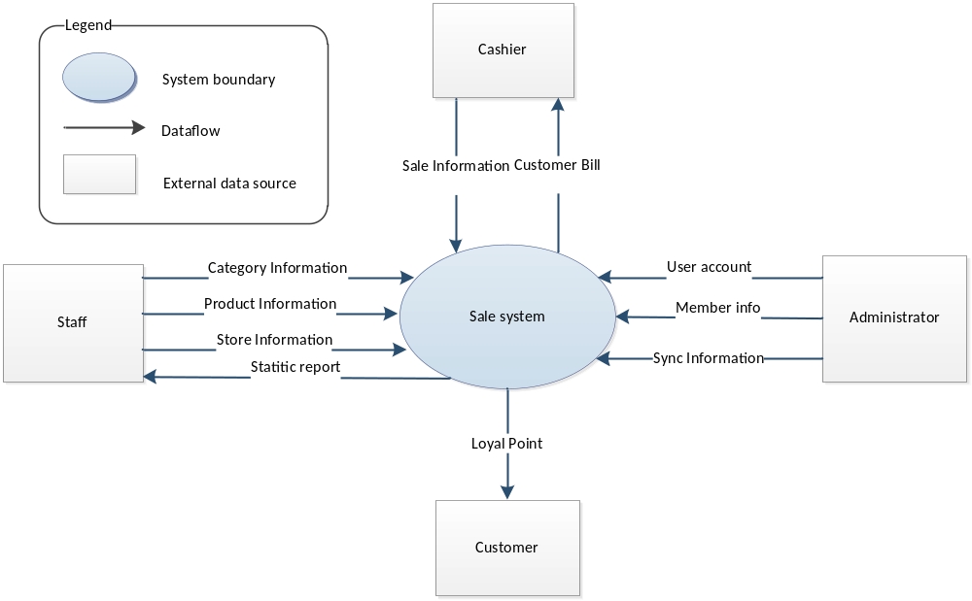
Users and roles: Stakeholders who interact to Retail system was described in section 2.3.Stakeholder of this document.
Channels: Users will use different channels to access the system.
Staff: Use PC locates at Head Office to access to system.
Cashier: Use Bar code reader at POS terminal to interacts with system
Customer: Use touch screen at POS terminal to access the system
Administrator: Use PC at Head Office to access the system
Relationship Describe:
The context diagram shows the input of stakeholders and output from system, direction of the arrows show the direction of information.
: Show that the input from user to the system
: Show that the output from system to the user

- Physic Perspective

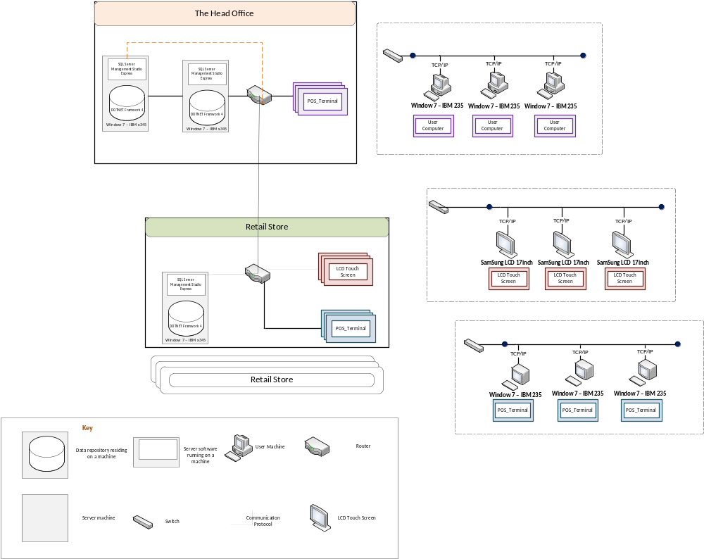
ở Head Office, hệ thống xây dựng bao gồm:
Dàn máy tính cho user được cài sẵn phần mềm quản lý. Chúng kết nối với nhau trong một hệ thống mạng LAN thông qua cục switch qua dây Ethernet
Có hai máy server, một máy server để hoạt động, một máy server dự phòng.
ở Retail Store, hệ thống xây dựng gồm có:
Cashier ở các Retail Store sử dụng các máy POS_terminal được kết nối với nhau trong cùng một hệ thống mạng LAN thông qua cục Switch
Khách hàng có khả năng yêu cầu hệ thống cho xem điểm của họ thông qua các màn hình cảm ứng đặt rải rác tại các Retail Store. Những màn hình cảm ứng này sẽ được cài phần mềm với giao diện dành riêng cho khách hàng, chúng kết nối với nhau thông qua mạng LAN bằng cục switch
Do scope của dự án nhóm đặt ra với công ty A đặt Head Office và các Retail Store nằm trong cùng một tòa nhà, nên việc kết nối giữa các nơi này nhóm sử dụng Router

- Static Perspective
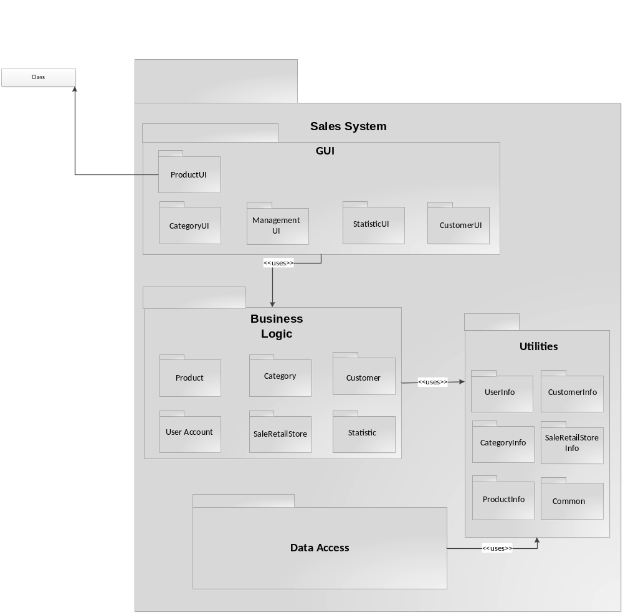
- Data Model
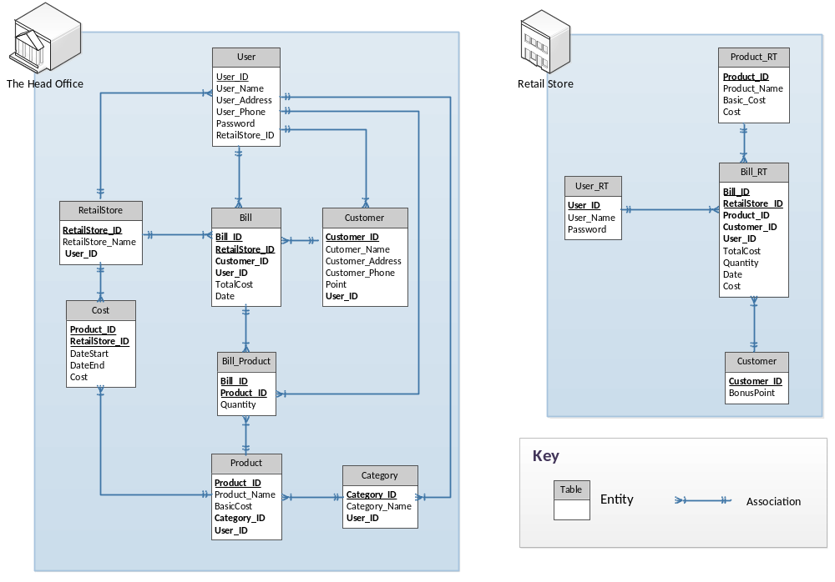
- Dynamic Perspective
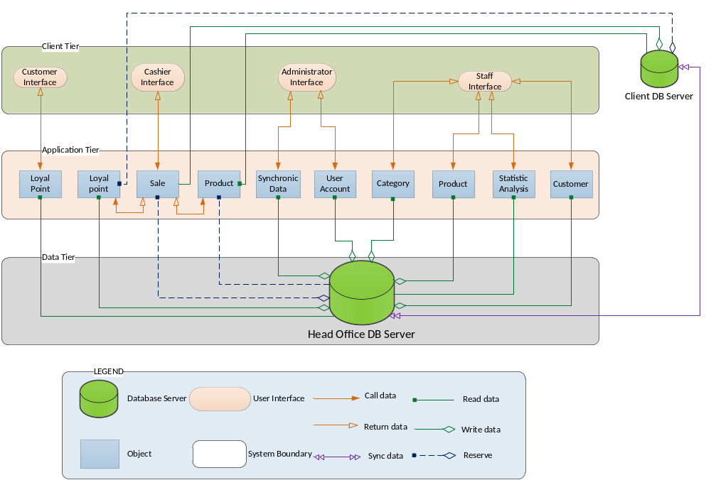

- Solution background
  - Architectural Approaches

Sử dụng mô hình client-server dùng mạng LAN.

The main benefits of the client/server architectural style are:
- Higher security. All data is stored on the server, which generally offers a greater control of security than client machines.
- Centralized data access. Because data is stored only on the server, access and updates to the data are far easier to administer than in other architectural styles.
- Ease of maintenance. Roles and responsibilities of a computing system are distributed among several servers that are known to each other through a network. This ensures that a client remains unaware and unaffected by a server repair, upgrade, or relocation.
- Dễ dàng thêm mới client vào hệ thống
Đảm bảo tính availability:
Khi máy chủ bị sụp, máy ở POS vẫn có thể tiếp tục thực hiện tiến trình mà không cần phải có thời gian chờ.
- Passive redundancy: Phân chia database phụ ở POS, khi thực hiện giao dịch sẽ đồng thời lưu dữ liệu vào database ở cả POS và head office. Khi database ở Head office bị sụp, dữ liệu vẫn có thể
Khi sảy ra sự cố trong quá trình thanh toán ở POS, những tiến trình đang được thực hiện dở dang sẽ được hủy bỏ
- Transactions: Khi sảy ra sự cố trong một bước bất kì của quá trình thanh toán, toàn bộ giao dịch sẽ được hủy!

Đảm bảo tính Performance:

Đảm bảo các thao tác ở POS phải được thực hiện nhanh chóng
- Reduce computational overhead: Để đảm bảo tính nhanh chóng trong các thao tác xử lý, hệ thống sẽ giảm thiểu sự trao đổi thông tin giữa các tầng. Tuy nhiên thì khả năng dễ dàng thay đổi của hệ thống sẽ giảm đi
- Increase available resources: tăng thêm phần cứng (tốc độ xử lý, bộ nhớ, đường truyền..). Tuy nhiên chi phí sẽ tăng lên

- Level X decomposition
- Decomposition description: Describe what is being decomposed and relate it back to the context drawing. Describe the perspective of the decomposition.
- Primary representation(s): Include one or more drawings (or views) that represent the decomposition of the system
- Description and rationale:
  - Describe the primary representation and include rationale for the decomposition.
  - Relate the architectural decisions to the architectural drivers by describing how the architectural drivers are promoted by the decisions and approaches taken.
  - Describe any design trade-offs relevant to the design decisions in terms of the architectural drivers promoted and inhibited.
- Elements and relations: Include element and relationship between them.
- Interface descriptions: If appropriate, describe specific interfaces for the elements. Whether detailed interfaces are described at any level of decomposition depends upon if there is enough detail in the decomposition.
- Mapping between perspectives
- Show mappings between structures in different perspectives if necessary.
- Show how specific structures in one perspective map to specific structures in other perspectives.
- Be careful in the mappings and use prose to describe any mappings you show.
- Document directory
In this section include an index, glossary, and acronym list

Câu hỏi
- Trong context diagram, timer có được gọi là một actor tác động vào hệ thống. Khi biết rằng nhiệm vụ của timer là đồng bộ 2 loại thông tin: sale và customer ở head office - retail store cứ mỗi 5 phút một lần.
- Trong Physic view, router có chức năng nhận biết một server bị hỏng thì tự động chuyển sang server dự phòng thông qua địa chỉ IP (biết rằng hai máy server đều được khởi động)

